CHEMICAL ENGINEERING TRANSACTIONS  VOL. , 2023 | A publication of
The Italian Association
of Chemical Engineering
Online at www.cetjournal.it

Guest Editor: Sauro Pierucci
Copyright © 2023, AIDIC Servizi S.r.l.
ISBN 978-88-95608-98-3; ISSN 2283-9216

Natural Polymers as Green Corrosion Inhibitors in Carbon Steels for Applications in Acid Environment
Juan Orozco-Agamezª, Anibal Alviz-Meza^{b,*}, Viatcheslav Kafarov^{c}, Darío Peñaª

ª | Universidad Industrial Santander, Escuela de Ingeniería Metalúrgica y Ciencia de los Materiales, Grupo de Investigaciones en Corrosión – GIC, cra 27 calle 9, Bucaramanga –Santander, Colombia
^{b} | Universidad Señor de Sipán, Facultad de Ingeniería, Arquitectura y Urbanismo, Grupo de investigación en Deterioro de Materiales, Transición energética y Ciencia de Datos DANT3, Km. 5 via Pimentel, Chiclayo, Perú.
^{c} | Universidad Industrial Santander, Escuela de Ingeniería Química, Centro de Investigación para el Desarrollo Sostenible en Industria y Energía – CIDES, cra 27 calle 9, Bucaramanga –Santander, Colombia
 | alvizanibal@crece.uss.edu.pe

Corrosion represents one of the major problems in using materials. As a result, finding ways to control it has become a permanent and complex task for industries, using toxic and dangerous techniques, producing great and serious problems for humanity. Natural polymers have emerged as one of the most promising alternatives for accurately and adequately mitigating corrosion through the use of biodegradable, non-toxic, inexpensive and effective materials. A series of studies on the inhibition efficiency of gums and lignins as natural corrosion inhibitors was compiled and analyzed in this study, focusing on avoiding the environmental impact of traditional corrosion inhibitors in carbon steels for acidic applications. Within the results, inhibition efficiencies were identified in gums from 74% to 97% and lignins from 79.9% to 92%, showing that, in general, the efficiency increases with a higher concentration of the inhibitor, however, when the temperature increases, tends to decrease the efficiency of physical adsorption, unlike chemical adsorption that tends to increase.
  - Introduction
One of the major problems that currently exists and that has been experienced for many years in the use of materials is corrosion (Song et al., 2022). Approximately 80 % of pipeline accidents are caused by corrosion, largely due to ferrous metals that are not adequately protected. Equipment deterioration should be minimized to avoid prolonged downtime and unnecessary expenditures (Orozco-Agamez et al., 2022). This problem has generated great concern on the part of research entities and companies around the world, who have developed measures that manage to limit, mitigate, and control this process. Many of the methods used have not been the most appropriate, since their processes do not protect the environment, and even become toxic to humans; this has generated research to focus on finding measures that attack corrosion, and that, in turn, benefit ecology and the economy. In this context, natural polymers currently represent an attractive alternative that adjusts to what is required from sustainable development in the fight against corrosion, due to its easy biodegradation, non-toxicity, reduced cost, availability, molecular structure, and the effect of its coverage on the metal surface (Wei et al., 2020).
Corrosion inhibitors are the type of coating that seeks to prevent the corrosion of materials, with the main objective of interrupting the electrochemical process by forming a layer. The inhibitors can be classified according to the chemical composition in organic and inorganic, in the same way, according to the mechanisms of action they can be anodic, cathodic, and mixed, the latter being capable of inhibiting or hindering the anodic and cathodic reactions simultaneously. As a result of physisorption or chemisorption, organic type inhibitors can form a layer on the material surface, which can act as a physical barrier and provide protection (Merchan-Arenas et al., 2018)
.
Generally, natural polymers are macromolecular substances composed of relatively simple structural units with low molecular weight and are found in plants and animals, especially in natural gums and in the lignin extracted from wood (Devi et al., 2020).
Gums have as main specifications that they are high molecular weight molecules made up of polymers of monosaccharide units and derivatives, linked by glycosidic bonds, achieving the formation of long chains, specifically locating in the cell walls of plants and microorganisms; while lignin stands out for being a type of natural polymer formed by a diversity of organization of monomers that are deposited in the cell walls of plants, in wood or bark, due to its excellent rigidity (Umoren et al., 2008). Furthermore, these components include alkaloids, pigments, amino acids, and organic tannins that exhibit inhibitory properties (Gooch, 2020). At present it is possible to find a series of research that individually report the inhibition efficiencies achieved in a particular way by the different natural polymers used. This research paper mainly aims to respond to the relationship that exists between the variables temperature, concentration, and immersion time with respect to the inhibition efficiency and corrosion rate of different natural polymers used in acid media. These mentioned variables represent critical variables of the processes, and it is imperative to identify the correlation between them.
    - Lignin
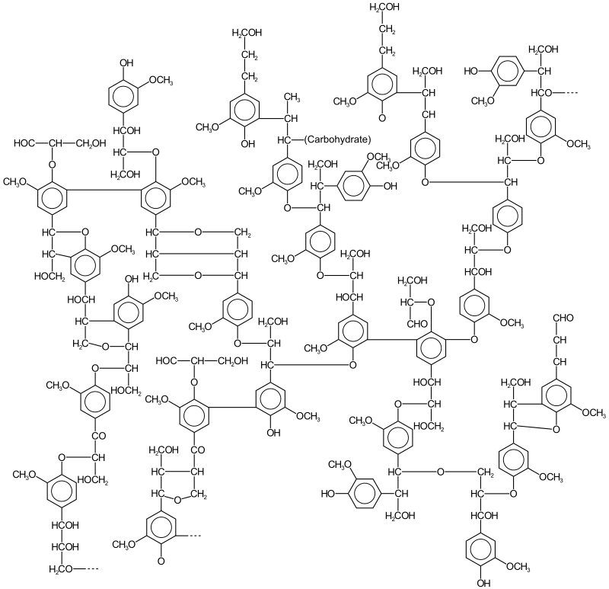
Figure 1. Lignin structure
This amorphous aromatic biopolymer comes primarily from the dry part of the plant, varying from 15 to 40% by weight (Shahini et al., 2021). Its structure can be seen in figure 1. It works as a binder to hold the fibers together, making them rigid (Hussin et al., 2015). Its main means of obtaining it is through the production of paper and other processes, leaving this material as a by-product or waste in large quantities. Despite this, certain uses have been found for this material such as batteries, ceramics, pharmaceuticals, among others. Furthermore, to our particular interest, a sufficiently high efficiency as a corrosion inhibitor, preventing the risk of pitting in the tested materials, has been reported (Shahini et al., 2021). These tests were carried out due to the high and diverse content of functional groups and phenylpropanoid structure, making lignin act as a neutralizer of oxidation processes thanks to reactions by oxygen radicals and their respective species (Hussin et al., 2016). These macromolecules are among the most abundant renewable resources in nature and their applications have not been exploited to the full due to the complexity and heterogeneity in their structures and their high molecular weight distributions (Gao et al., 2021). It is also the second most abundant biopolymer after cellulose (Shahini et al., 2021).

    - Gums

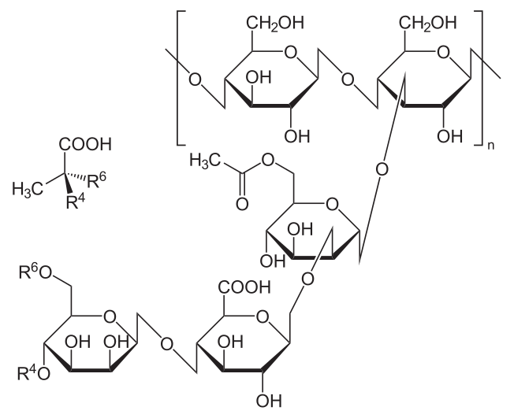
Figure 1. Xanthan gum structure
Vegetable gums are ecological, economical, readily available, non-hazardous and renewable (Mobin et al., 2020), having very varied uses such as pharmaceutical materials, in food industries and many more, being of special interest when looking for good inhibitors of corrosion, and they are so thanks to their long polymeric structures, with their functional groups (OH, COOH, NH₂, etc.) that form complexes with metal ions, covering the surface, and in turn preventing metal corrosion. Due to its composition, it contains high levels of oligosaccharides, polysaccharides, glycoproteins, arabinogalactans, and sucrose, as well as nitrogen and oxygen atoms that serve as adsorption centers (Wei et al., 2020). The structure of the xanthan gum can be seen in figure 2.
  - Temperature
The temperature directly affects the efficiency that natural polymers achieve on metal surfaces, because the type of organic inhibitor is codependent with its adsorption mechanism, varying whether it is physical or chemical. When the temperature rises and exceeds the activation energy threshold, the inhibitor undergoes a desorption process. The Arrhenius equation can be used to determine this energy.
Where various lignins occur as green inhibitors, which generally attribute a greater weight loss to an increase in temperature, which may indicate a lower efficiency of the inhibitor, caused by the desorption of the adsorbent (Shahini et al., 2021). The type of adsorption matters and is evidenced in the activation energy required for each case, since for a type of chemical adsorption there will generally be a much higher activation or barrier energy, while in a physical adsorption reaction will be relatively low.
A type of mixed adsorption illustrates this inverse relationship with temperature by showing a drop in efficiency from 95% at 30°C to 83% at 60°C under the same conditions (Azzaoui et al., 2017). However, for some cases of chemical or mixed adsorption, there is a slight increase in the adsorption capacity and therefore in the inhibition efficiency as the temperature increases, until the activation energy limit is reached. An example of this is shown in a study where almond gum was evaluated, which presented a mixed type of adsorption, in which the temperature increased the inhibition percentage, reaching 85.5% at 30°C up to 96.37% at 60ºC (Mobin et al., 2020).
  - Concentration
In a study carried out on the natural polymer polyethylene glycol in an acid medium, it was determined that as the concentration of said polymer increased, the inhibition percentage tended to increase, evidencing a directly proportional relationship. Likewise, for RaphiaHookeri gum, the inhibition efficacy increased when the concentration of said polymer increased (Arthur et al., 2013).

The study "Floxacins: as Mediators in Enhancing the Corrosion Inhibition Efficiency of Natural Polymer Dextrin" shows the relationship between the composition and the variables inhibition efficiency and corrosion rate, taking the natural polymer Dextrin as a case study. The different electrochemical measurements show how the concentration and the type of the polymer structure help to improve or deficient the percentage of inhibition.

Figure 1 shows the behavior of the concentration vs. the percentage of inhibition efficiency, as well as the concentration vs. corrosion rate. It is observed that as the concentration of said polymer increases, the inhibition efficiency grows proportionally, as well as a decrease in the corrosion rate (Devi et al., 2020).
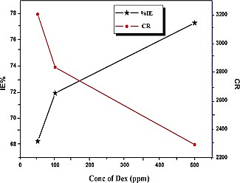
Figure 2. Dextrin behavior with respect to concentration, inhibition efficiency percentage and corrosion rate (Devi et al., 2020).
  - Immersion time
The immersion time is a fundamental variable for an adequate selection of the inhibitor to achieve high inhibition efficiencies, which, like the concentration of the polymer, or the temperature become critical variables.
In a study carried out on the inhibition efficiency of moringa gum in an acid medium, it was possible to establish that as the immersion time increases, the inhibition efficiency increases, although this happens after 6 hours, where it begins. decrease. This occurs because the natural polymer biodegrades, thus affecting the inhibition efficiency (Jalajaa et al., 2019).
Table 1: concentration vs time immersion. Adapted from (Jalajaa et al., 2019).
Concentration  Goma Moringa (g/L) | 1 hour |  |  | 2 hours |  | 4 hours |  | 6 hours |  | 8 hours
 | CR (mmpy) |  | IE (%) | CR (mmpy) | IE (%) | CR (mmpy) | IE (%) | CR (mmpy) | IE (%) | CR (mmpy) | IE (%)
2 | 0,01668 | 63,33 |  | 0,02199 | 63,46 | 0,01621 | 66,27 | 0,02066 | 75,61 | 0,03878 | 29,48
4 | 0,01596 | 64,89 |  | 0,02000 | 66,77 | 0,01362 | 71,65 | 0,00670 | 92,10 | 0,03100 | 43,62
6 | 0,01251 | 72,50 |  | 0,01200 | 80,06 | 0,00931 | 80,63 | 0,00518 | 93,89 | 0,02280 | 58,53
8 | 0,01195 | 73,75 |  | 0,00749 | 87,56 | 0,00554 | 88,46 | 0,00489 | 94,24 | 0,01858 | 66,21
10 | 0,00906 | 80,08 |  | 0,00711 | 88,35 | 0,00536 | 88,86 | 0,00386 | 95,46 | 0,01891 | 65,60

The immersion time is an important variable that is directly related to the inhibition efficiency and the morphology of the materials. When immersion time is increased, gums and lignins exhibit a higher inhibitory efficiency, but a limit can be reached. Since natural polymers can undergo biodegradation over long periods of time, which would affect inhibition properties, controlling the times in which they are used becomes essential.
  - Conclusions

Considering the variables of temperature, concentration, immersion time in relation to corrosion rate and inhibition efficiency in carbon steels for applications in acid environments, natural polymers such as gums and lingnins were evaluated.

Results showed that corrosion rates increased as temperature increased. At the same time, increasing the concentration the inhibition effect is improved accordingly.

The immersion time is a critical variable for the dynamization in the industry of gums and lignins as natural inhibitors. According to the researchers analyzed with the study concentrations, these inhibitors reach acceptable inhibition efficiencies up to six hours. After this time the corrosion rate begins to increase because of the biodegradation of natural polymers.
  - References
Arthur D. E., Jonathan A., Ameh P. O., Anya C., 2013, A review on the assessment of polymeric materials used as corrosion inhibitor of metals and alloys. International Journal of Industrial Chemistry, 4, 1-9.
Azzaoui K., Mejdoubi E., Jodeh S., Lamhamdi A., Rodriguez-Castellón E., Algarra M., Zarrouk A., Errich A., Salghi, R., Lgaz H., 2017, Eco friendly green inhibitor Gum Arabic (GA) for the corrosion control of mild steel in hydrochloric acid medium. Corrosion Science, 129, 70–81.
Devi G. N., Unnisa C. B. N., Roopan S. M., Hemapriya V., Chitra S., Chung I. M., Kim S. H., Prabakaran M., 2020, Floxacins: as Mediators in Enhancing the Corrosion Inhibition Efficiency of Natural Polymer Dextrin. Macromolecular Research, 28, 558– 566.
Guo L., Zhang R., Tan B., Li W., Liu H., Wu S., 2020, Locust Bean Gum as a green and novel corrosion inhibitor for Q235 steel in 0.5 M H2SO4 medium. Journal of Molecular Liquids, 310,1-12.
Hussin M. H., Rahim A. A., Mohamad Ibrahim M. N., Brosse N., 2016, The capability of ultrafiltrated alkaline and organosolv oil palm (Elaeis guineensis) fronds lignin as green corrosion inhibitor for mild steel in 0.5 M HCl solution. Measurement: Journal of the International Measurement Confederation, 78, 90–103.
Hussin M. H., Shah A. M., Rahim A. A., Ibrahim M. N. M., Perrin D., Brosse N., 2015, Antioxidant and anticorrosive properties of oil palm frond lignins extracted with different techniques. Annals of Forest Science, 72, 17–26.
Jalajaa D., Jyothi S., Muruganantham V. R., Mallika J., 2019, Moringa oleifera gum exudate as corrosion inhibitor on mild steel in acidic medium, Rasayan Journal of Chemistry, 12, 545–548.
Mobin M., Ahmad I., Basik M., Murmu M., Banerjee P., 2020, Experimental and theoretical assessment of almond gum as an economically and environmentally viable corrosion inhibitor for mild steel in 1 M HCl. Sustainable Chemistry and Pharmacy, 18, 1-18.
Merchan-Arenas D., Sanabria-Cala J., Cortes-Castillo L., Camacho D., Vesga G., Peña-Ballesteros D., Kouznetsov V., 2018, Electrochemical evaluation of the corrosion rate inhibition capacity of eugenol, o-eugenol and diphenol, on AISI 1020 Steel Exposed to 1M HCl Medium. Chemical Engineering Transactions, 64, 247–252.
Orozco-Agamez J., Tirado D., Umaña L., Alviz-Meza A., Garcia S., Peña D., 2022, Effects of Composition, Structure of Amine, Pressure and Temperature on CO2 Capture Efficiency and Corrosion of Carbon Steels using Amine-Based Solvents: a Review. Chemical Engineering Transactions, 96, 505–510.
Shahini M. H., Ramezanzadeh B., Mohammadloo H. E., 2021, Recent advances in biopolymers/carbohydrate polymers as effective corrosion inhibitive macro-molecules: A review study from experimental and theoretical views. Journal of Molecular Liquids, 325, 1-18.
Song W., Dayu X., Mingxing L., Ansari K. R., Singh A., 2022, Insight into the anti-corrosion performance of synthesized novel nano polymeric material of SiO2 for the protection of J55 steel in 3.5 wt% NaCl solution saturated with carbon dioxide. Journal of Natural Gas Science and Engineering, 106, 1-9.
Umoren S. A., 2008, Inhibition of aluminium and mild steel corrosion in acidic medium using Gum Arabic, Cellulose, 15(5), 751–761
Wei H., Heidarshenas B., Zhou L., Hussain G., Li Q., Ostrikov K., 2020, Green inhibitors for steel corrosion in acidic environment: state of art, Materials Today Sustainability, 10, 1-21.

